
PERTH COLLEGE

Trial WACE Examination, 2011

Question/Answer Booklet

MATHEMATICS
If required by your examination administrator, please place your student identification label in this box

3C/3D

Section Two:

Calculator-assumed

Student Number: In figures

In words

Time allowed for this section
Reading time before commencing work: ten minutes
Working time for this section: one hundred minutes

Material required/recommended for this section

To be provided by the supervisor
This Question/Answer booklet
Formula sheet (retained from Section One)

To be provided by the candidate
Standard items: pens, pencils, pencil sharpener, eraser, correction fluid/tape, ruler, highlighters

Special items: drawing instruments, templates, notes on two unfolded sheets of A4 paper,
and up to three calculators satisfying the conditions set by the Curriculum
Council for this examination.

Important note to candidates

No other items may be taken into the examination room. It is your responsibility to ensure that you do not have any unauthorised notes or other items of a non-personal nature in the examination room. If you have any unauthorised material with you, hand it to the supervisor before reading any further.

Structure of this paper

Section | Number of questions available | Number of questions to be answered | Working time (minutes) | Marks available
Section One:  Calculator-free | 7 | 7 | 50 | 40
Section Two:  Calculator-assumed | 12 | 12 | 100 | 80
 |  |  |  | 120

Instructions to candidates

- The rules for the conduct of Western Australian external examinations are detailed in the Year 12 Information Handbook 2011. Sitting this examination implies that you agree to abide by these rules.

- Write your answers in the spaces provided in this Question/Answer Booklet. Spare pages are included at the end of this booklet. They can be used for planning your responses and/or as additional space if required to continue an answer.
- Planning: If you use the spare pages for planning, indicate this clearly at the top of the page.
- Continuing an answer: If you need to use the space to continue an answer, indicate in the original answer space where the answer is continued, i.e. give the page number. Fill in the number of the question(s) that you are continuing to answer at the top of the page.

- Show all your working clearly. Your working should be in sufficient detail to allow your answers to be checked readily and for marks to be awarded for reasoning. Incorrect answers given without supporting reasoning cannot be allocated any marks. For any question or part question worth more than two marks, valid working or justification is required to receive full marks. If you repeat an answer to any question, ensure that you cancel the answer you do not wish to have marked.

- It is recommended that you do not use pencil except in diagrams.

Section Two: Calculator-assumed [80 Marks]

This section has twelve (12) questions. Answer all questions. Write your answers in the
space provided. Suggested working time for this section is 100 minutes.

Question 8 [4 marks]

The marginal costs involved in printing x copies of a particular book follow the rule

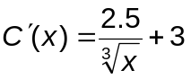

a) Write an expression involving integration which can be used to determine the extra cost incurred by producing 1000 copies rather than 500. (1 mark)

b) Use the expression in part a) above to determine the average cost per book of producing the second 500 books. (1 mark)

c) Use the marginal rate to estimate the cost of printing one more book at the stage in the printing when 1000 copies have been produced. Compare this cost with the average cost of producing the second 500 copies of the book. (2 marks)

Question 9 [8 marks]

A drink company makes a fresh fruit drink every day using a combination of apples and pears. The recipe requires that the weight of apples must be no more than twice that of pears and at the same time the weight of the pears together with twice the weight of apples must be at least 160kg. Daily supplies are limited to 100kg of apples and 90kg of pears.
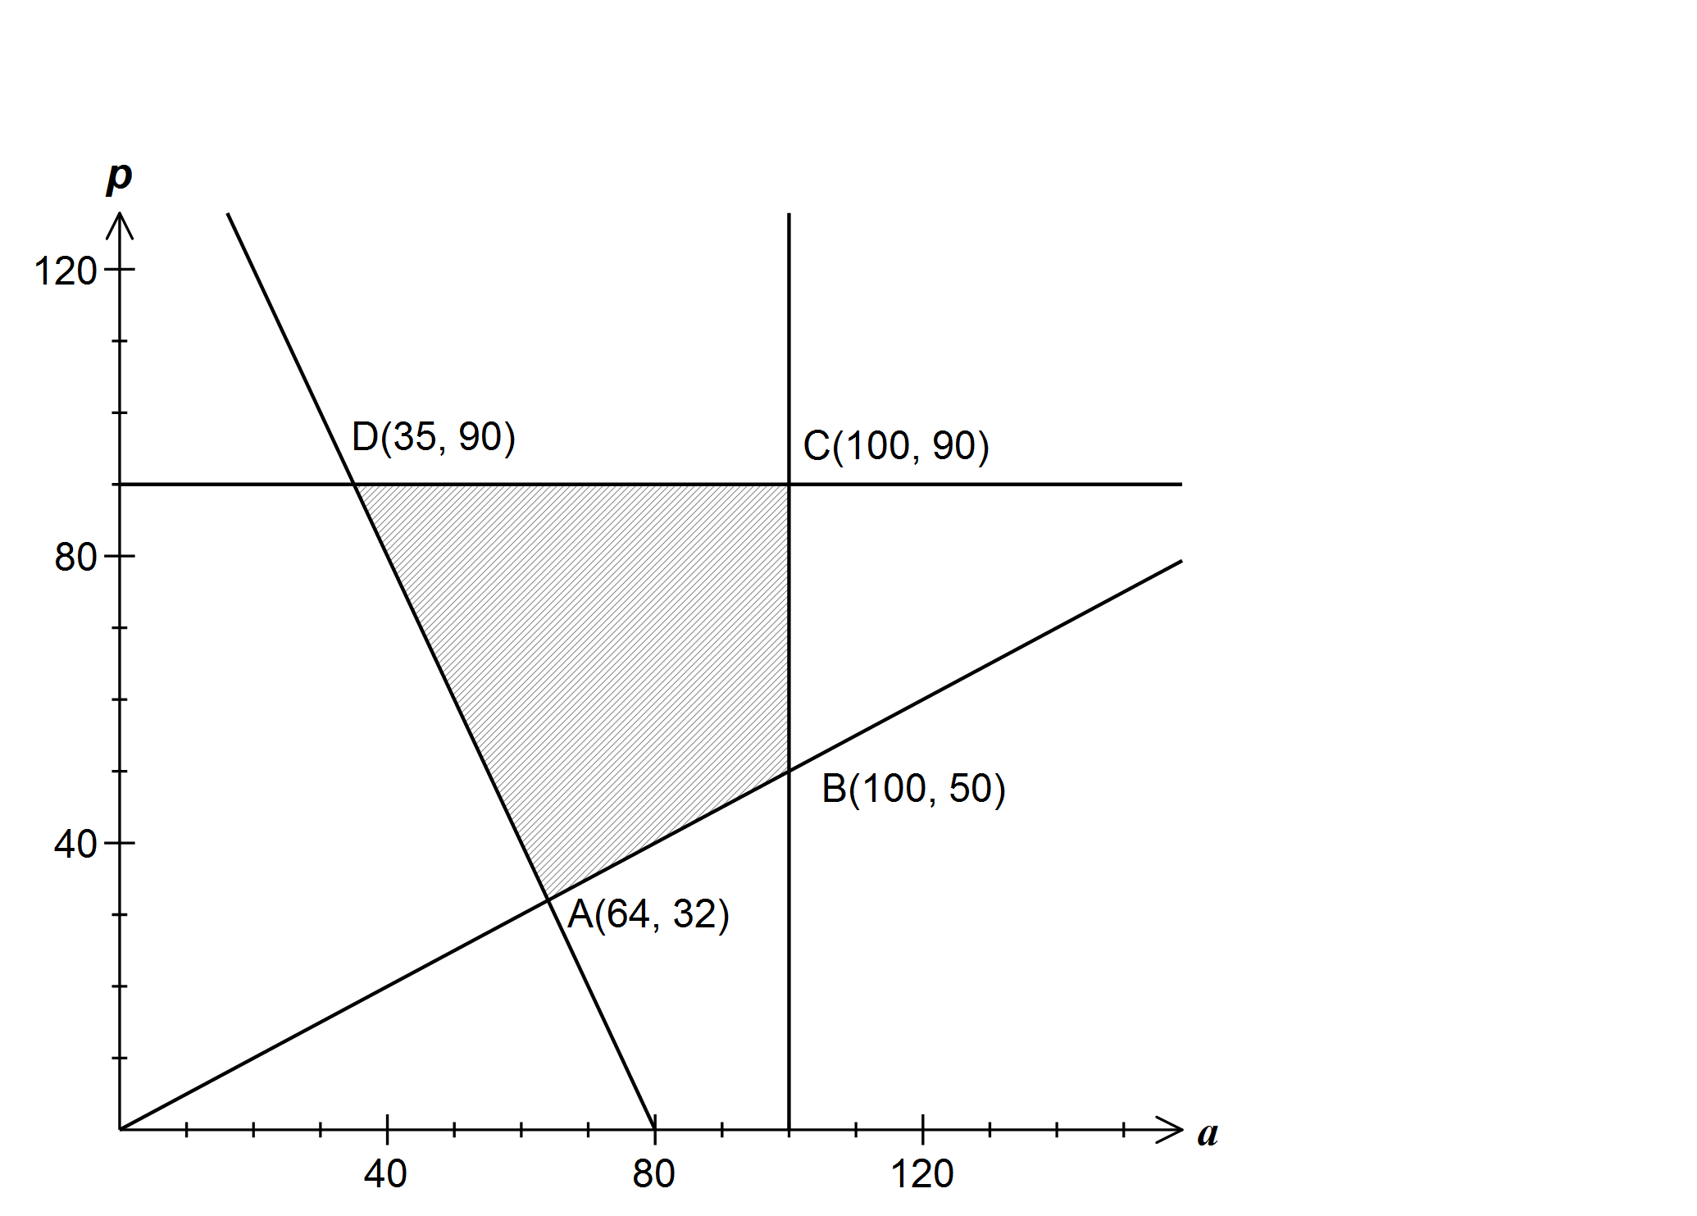
Let a represent the weight of apples used and p the weight of pears used. The feasible region for this information is shown on the graph below.

From a practical point of view, the company have another constraint such that twice the weight of the apples added to three times the weight of pears must be at least 280kg.

(a) Add this fifth constraint to the graph above and clearly shade and label the vertices
of the new feasible region. (3 marks)

(b) If the price of apples is $1.80 per kg and pears $2.20 per kg, find the minimum daily cost of fruit whilst satisfying all the above constraints. (2 marks)

(c) Consider the situation where the price of apples fell to $1.70 per kg but the price of pears fell considerably more. Given that the vertex in part (b) still yielded the minimum cost, what would be the minimum price of pears on this day? (3 marks)

Question 10 [8 marks]

(a) A team of 3 students is chosen at random from a group of 4 girls and 5 boys for a TV game show. What is the probability that the team chosen consists of at least one girl? (2 marks)

(b) In one of the games, the team choose one of four closed doors. The doors then open to reveal a prize placed at random behind just one of them. The team keep the prize if they are correct. How many rounds of this game must the team play so that the probability of them obtaining at least one prize is greater than 0.95?
(3 marks)

(c) At the close of the show, the team can select one of two boxes to keep as another prize. Inside each of the boxes are five sealed envelopes, each containing a voucher. In one of the boxes, four of the vouchers are worth $10 000 and the fifth $100, whilst in the other box two of the vouchers are worth $10 000 and the other three, $100 each.

The team is allowed to choose an envelope from one of the boxes and open it. They must then decide whether to keep that box or choose the other one. The team plan to keep the box that the envelope they opened came from if it contains a $10 000 voucher. Otherwise they will take the other box.

What is the probability that the team wins more than $30 000? (3 marks)

Question 11 [7 marks]
A particle, initially at the origin, moves in a straight line such that its velocity v m/s at time t seconds is given by
v = 3t – t² – 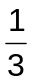t³
(a) Find the time when its velocity is maximum. (2 marks)

(b) Find how far is the particle from the origin when t = 3 seconds. (2 marks)

(c) For how long was the acceleration of the particle negative? (2 marks)

(d) Find the total distance travelled during the first 3 seconds. (1 mark)

Question 12 [7 marks]

- Determine the value of the constants k and c so that each function below represents the distribution of a random variable over the given domain.

i) f(x) = kx (4 – x) for x = 0, 1, 2, 3, 4 (1 mark)

ii) g(x) = 2.5 – 2x for 0 ≤ x ≤ c (2 marks)

b) A statistician takes his pet mastiff, Fifi, for a walk every day. Over a period of some months, he noticed that the length of time taken to walk Fifi varied from 45 to 70 minutes, and that it followed a uniform distribution.

- Determine the probability that Fifi’s daily walk was less than 50 minutes.
(1 mark)

- Determine the probability that, in a particular week, Fifi had at least two walks of
less than 50 minutes given that she had less than five walks of less than 50
minutes.
(3 marks)

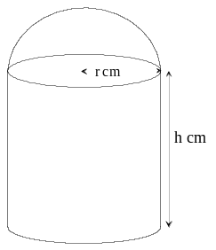Question 13 [6 marks]
The manufacturers of a tennis ball container in the shape of
an opened top cylinder, with a hemisphere above it, are looking
to save costs on packaging. The volume of the container
is 45π cm³.

a) Show that r²h + 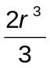 = 45 (1 mark)

b) Show that the external surface area A of the container is given by

A = 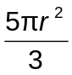 + 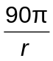 (2 marks)

c) Use Calculus to determine the dimensions of the container that will minimise the surface area. State this surface area. (3 marks)

Question 14 [4 marks]
The following pairs of fractions produce the same result if they are added together as
when they are multiplied together.

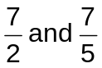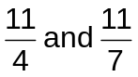

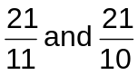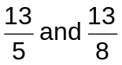

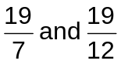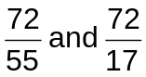

These pairs of fractions are all in the form 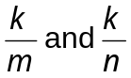

a) State the relationship that is shown between the numerator k, and the denominators m and n. (1 mark)

b) For any pair of fractions where k has this relationship with m and n, prove that will produce the same result as 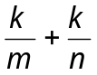 (3 marks)

Question 15 [5 marks]
A cubical six-sided dice is known to be biased. It is thrown 3 times and the number of sixes is noted. This experiment is then repeated 200 times and the results are shown in the table.

Number of sixes | 0 | 1 | 2 | 3
Frequency | 67 | 93 | 33 | 7

(a) What is the mean number of sixes? (1 mark)

(b) What is the probability of obtaining a six when this dice is thrown? (1 mark)

(c) Use a suitable binomial distribution to calculate how many times you would expect theoretically, to obtain 1, 2 and 3 sixes in 200 such experiments. Comment on how well your distribution models the experimental results above. (3 marks)

Question 16 [7 marks]
At his part-time job working in a cafe, mathematician Barry Easter noticed that, as cups of
black coffee cooled, the temperature (T°C) t minutes after they had been made follows the
exponential function
T = 75e^{-0.1t} + 20

a) Describe the transformations of the function T = e^{t} required to produce this function. (2 marks)

b) What is the initial temperature of the coffee when it is made? (1 mark)

c) If left to cool, eventually the temperature of the coffee will be the same as the temperature of the cafe. What is this temperature? (1 mark)

d) The ideal serving temperature for a cup of black coffee is 70°C. For how many minutes after the coffee is made should Barry wait before serving it? (1 mark)

e) One of Barry’s customers had let their coffee get cold, and asked him to re-heat it.
The re-heating process is such that the rate of change of the temperature (°C/min) is given by 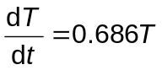, where T (in ᵒC) is the temperature of the coffee t minutes after the reheating process.

(i) If the coffee was at a temperature of 25°C when Barry began to re-heat it, write an expression for the temperature T ( in ᵒC), t minutes after the reheating process commences. (1 mark)

(ii) Determine how long the reheating process would take to make the coffee reach ideal serving temperature of 70°C once more. (1 mark)
Question 17 [11 marks]
A bottling machine fills bottles of water. The content, X mL, of the bottles is a normally distributed random variable with a mean of 391 mL and a standard deviation of 8.15 mL.

It is known that 1 out of every 200 bottles that the machine fills has less than the stated contents on the bottle label.

24 bottles are packed in a carton and 48 cartons are loaded onto a shipping pallet.

(a) What is the probability that a bottle contains more than 375 mL of water? (1 mark)

(b) What are the stated contents on the bottle label? (2 marks)

(c) What is the probability that a pallet contains at least one bottle with less than the stated contents? (2 marks)

(d) The bottling company randomly choose a pallet from the stockyard. The mean content of all the bottles from this pallet is 389.9 mL.

(i) Construct a 90% confidence interval for the mean content of all bottles.
(3 marks)

(ii) Should the interval be of concern to the bottling company? (1 mark)

(e) The bottling company wanted to send a sample of bottles to a retail outlet for distribution. What is the minimum size of the sample required for the company to be 99% confident that the mean volume of the sample is within 3 mL of the population mean of 391 mL?
(2 marks)

Question 18 [7 marks]
(a) The diagram shows part of the curve y = 2x², and A is the point (a, 0), AB is parallel to the y-axis and BC is parallel to the x-axis.

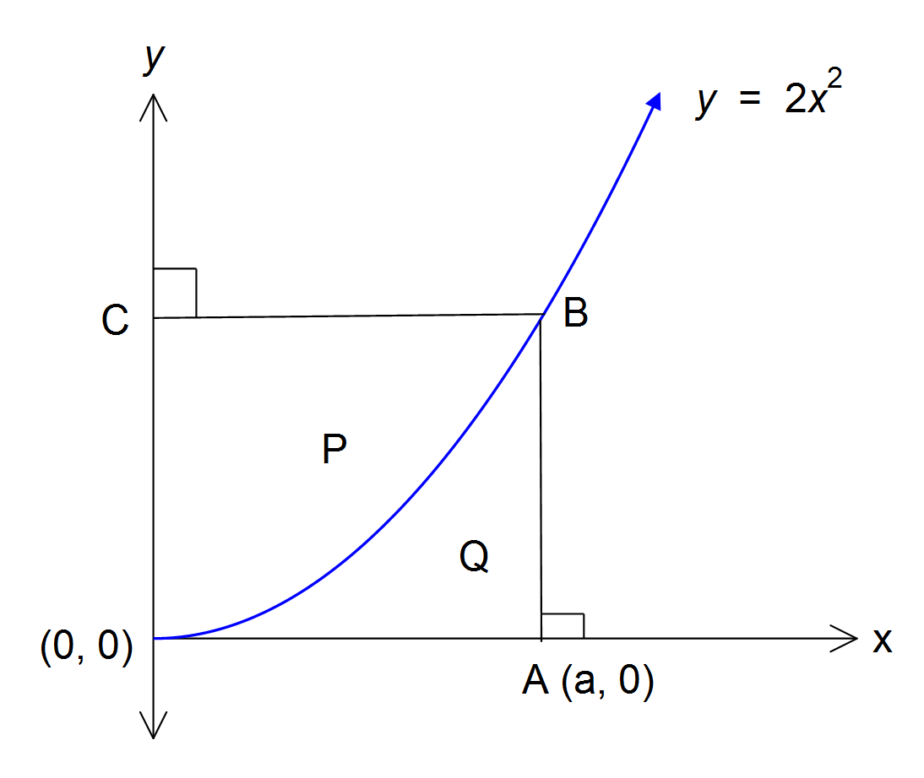

Show that the area of region P is twice that of region Q. (4 marks)

(b) A semi-ellipse can be formed by graphing the equation y = k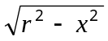 over its natural domain, with centre at (0, 0). The horizontal radius of this ellipse is r units, and the vertical radius is of length kr units, where k is a constant.
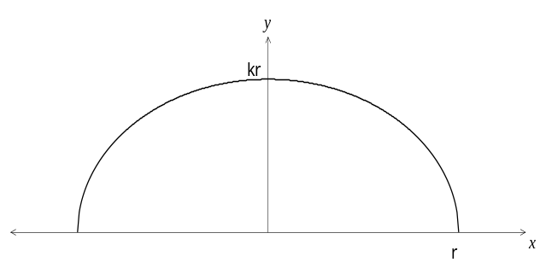

An ovoid (3 dimensional ellipse) is obtained by rotating this function 360° around the x-axis, over its natural domain. Show algebraically that the volume, V, of the ovoid is given by the formula
(3 marks)

Question 19 [6 marks]

Oil is poured onto the surface of a large tank of water at a rate of 0.7 cm³ per second. It spreads out on the surface to form a circular slick of uniform thickness 0.15 cm which can be modelled by a thin cylindrical shape.

(a) At what rate is the radius of the slick increasing one minute after pouring began?
(3 marks)

(b) (i) Use the incremental formula 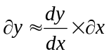 to estimate the change in the volume
as the radius increases from 55 cm to 55.5 cm. (2 marks)

(ii) Hence, determine the time it would take for this to occur. (1 mark)

END OF EXAMINATION
Additional working space
Question number(s):

Additional working space
Question number(s):

Additional working space
Question number(s):

Section One
 |  | Your Mark
Total | 40

Section Two

Question  Number | Available  Marks | Your Mark
8 | 4
9 | 8
10 | 8
11 | 7
12 | 7
13 | 6
14 | 4
15 | 5
16 | 7
17 | 11
18 | 7
19 | 6
Total | 80

 |  | Your Mark
Total | 120
 |  | %

